Abstract— In this lab, the Audio/BumpBot was modified by removing the sound sensor and attaching an ultrasonic sensor This bot was created to never get stuck in a corner or against a wall. The bot did not drive into any wall of an enclosed area.
Lab # 4 - RangeBot
Kit #: 15
Barak Barclay

INTRODUCTION

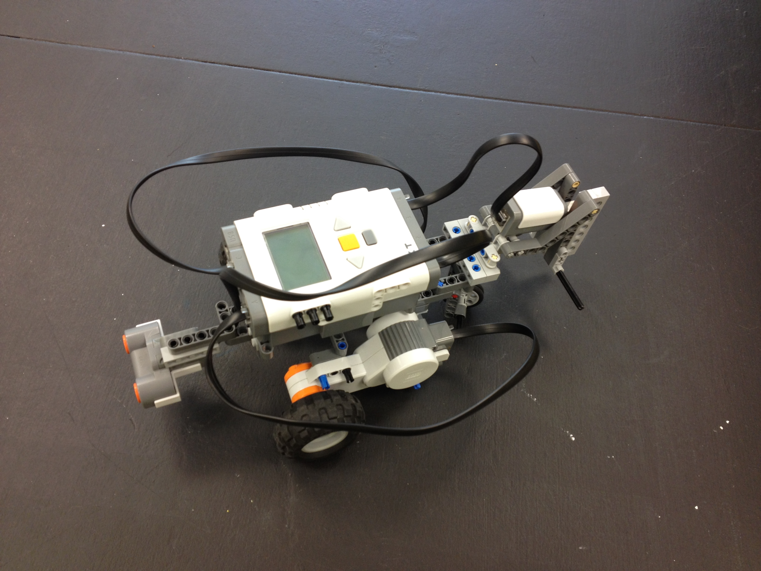
Figure 1. Picture of the RangeBot

Task 1: Program: Ultrasonic Sensor
In the program, ultrasonic sensor was configured and the LCD displayed the value of the sensor. This was done using a infinite while loop and the code below:

eraseDisplay();
displayTextLine (1, "%d", SensorValue[S1]);
wait1Msec(1000);

Task 2: Program: Measure Distance
Using the program from task one, the LCD displayed centimeters, as well as inches. It also played a sound file when it was less than 10cm from a wall. The sound file had to be downloaded to the brick. Below is the code used to display inches on the screen.

float distance_in = 0.0;
distance_in = SensorValue[S1]/2.54;
displayTextLine (2, "%d", distance_in);

Task 3: Program: Escape
The program was designed to use the ultrasonic sensor to escape from a three sided box. If the touch sensor was hit at any time while trying to escape, it stopped the bot and played a sound. The biggest part of the program was using a while loop to run until the bot sensed an escape. The code for the while loop is below:

while (SensorValue[S1] < 120)
{
}

Results

Task 1: Program: Ultrasonic Sensor
The ultrasonic sensor had to be re-positioned to accomplish the task. A variable was placed in the code when it was first written, but it was taken out after realizing that it was not needed. Using data from running the program, an excel chart of the sensor value versus inches was created:
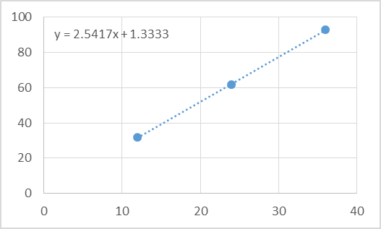
Figure 2. Graph of Sensor Value Vs. Inches

Task 2: Program: Measure Distance
The code for the sound was done exactly how the code for sound was done in the last lab. The sensor value turned out to be centimeters and just had to show an additional line for inches. There were no problems with this except for using a variable instead of a float at first.

Task 3: Program: Escape
Many problems arose from this task. Most of the code was scrapped completely and re-done. There were more while loops being used than needed and the program kept doing un-wanted things. After pretty much scrapping the program and starting new with one while loop, the program ran without any hitches.

Conclusion
The results came out as expected after the bot was built well and the code was written correctly. There are a couple takeaways to get from this lab. For one, a float, integer or variable need to be used for different things and need to be remembered. Also, sometimes you need to almost completely start a program over if there are too many mistakes to be corrected.

Appendix

Task 1: Program: Ultrasonic Sensor
#pragma config(Sensor, S1, USSensor, sensorSONAR)

task main()
{
while (true)
{
eraseDisplay();
displayTextLine (1, "%d", SensorValue[S1]);
wait1Msec(1000);
}
}

Task 2: Program: Measure Distance
#pragma config(Sensor, S1, USSensor, sensorSONAR)

task main()
{
while (true)
{
float distance_in = 0.0;
distance_in = SensorValue[S1]/2.54;
eraseDisplay();
displayTextLine (1, "%d", SensorValue[S1]);
displayTextLine (2, "%d", distance_in);
if (SensorValue[S1] < 10)
{
playSoundFile("danger_x.rso");
}
wait1Msec(1000);
}

}

Task 3: Program: Escape
#pragma config(Sensor, S1, USSensor, sensorSONAR)
#pragma config(Sensor, S4, touchSensor, sensorTouch)

task main()
{
while (SensorValue[S1] < 120)
{
motor[motorC]= -30;
motor[motorA]= 30; // Turn motor A on 50%
bFloatDuringInactiveMotorPWM = false; //motors will brake when power is set to "0"
if (SensorValue[S4] == 1)
{
playSoundFile("danger_x.rso");
motor[motorA]= 0; // Turn Motor A off
motor[motorC]= 0;
wait1Msec (1000); // Delay
}
}
motor[motorC]= -30;
motor[motorA]= 30; // Turn motor A on 50%
wait1Msec (300); // Delay
motor[motorA]= 0; // Turn Motor A off
motor[motorC]= 0;
wait1Msec (1600); // Delay
motor[motorC]= 30;
motor[motorA]= 30; // Turn motor A on 50% (Turn around)
wait1Msec (5000); // Delay
motor[motorA]= 0; // Turn Motor A off
}

References
- Figure One Taken from Barak’s phone.
- Figure Two Created in Lab.
- D. Parker. (2007) [Online]. Available: http://www.nxtprograms.com/

Barak Barclay: My hobbies include reading, watching movies, watching TV shows, camping, hiking, playing guitar, playing keyboard, skiing, snowboarding, working out, going to concerts, playing video games, swimming and rock climbing. I want to start going rafting, canoeing, kayaking and shooting at archery ranges too. I am an engineering student at UCCS.

 

